Lab 8 - STAT 123

Eric Huber

23/03/2022

## Question 1:

### (1.a)

df = read.csv("nba_player_data_2020.csv")

### (1.b)

df = na.omit(df)  
row_sub = apply(df, 1, function(row) all(row!=0))  
df = df[row_sub,]

### (1.c)

dfc = df[, c(13:16,18:20)]

## Question 2:

colours = c("dodgerblue", "firebrick1", "green3", "orange", "salmon", "slateblue1")  
  
cnames = c("2pt makes", "2pt attempts", "2pt %", "FT makes", "Ft attempts", "FT %")  
  
par(mfrow= c(2,3))  
par(mar = c(5.1, 4.1, 5.1,2.1))  
n = dim(dfc)[1]  
m = dim(dfc)[2]  
  
for(i in 2:m){  
 ttl = paste("3pt % vs", cnames[i-1])  
 plot(dfc[,i], dfc[,1], main = ttl, ylab = "3pt %", col = colours[i-1], xlab = cnames[i-1])  
   
 i = i+1  
   
}  
mtext("Correlation Plots", side = 3, line = -1.5, outer = TRUE)

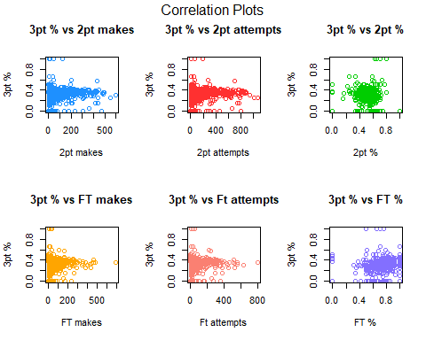

## Question 3:

### a  
cor_vec = numeric()  
  
### b  
for(k in 1:m){  
 cor_vec[k] = cor(dfc[,1],dfc[,k])  
   
 k = k+1  
}  
  
### c  
names(cor_vec) = c("3pt %", cnames)  
  
### d  
cor_vec

## 3pt % 2pt makes 2pt attempts 2pt % FT makes Ft attempts   
## 1.00000000 0.09377243 0.11069183 -0.04220238 0.11588018 0.09440999   
## FT %   
## 0.13846909

## Question 4:

## a  
easy_way = cor(dfc)[,1]  
names(easy_way) = c("3pt %", cnames)  
  
## b   
easy_way

## 3pt % 2pt makes 2pt attempts 2pt % FT makes Ft attempts   
## 1.00000000 0.09377243 0.11069183 -0.04220238 0.11588018 0.09440999   
## FT %   
## 0.13846909

(4.c) Besides 3pt % which is of course perfectly and positively correlated, the most positively correlated is the free throw percentage (FT %).